Chapter 7, Solution 6.

The switch in Fig. 7.85 has been closed for a long time, and it opens at t = 0. Find v(t) for t ≥ 0.

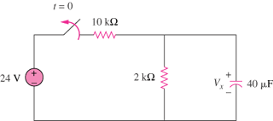
v(t)

40 V

Figure 7.85
For Prob. 7.6.

Solution

